
3 Health and Fitness
UNIT

Nouns

Residents of Shanghai, China, exercise with fans.

Copyright 2015 Cengage Learning. All Rights Reserved. May not be copied, scanned, or duplicated, in whole or in part. Due to electronic rights, some third party content may be suppressed from the eBook and/or eChapter(s).
Editorial review has deemed that any suppressed content does not materially affect the overall learning experience. Cengage Learning reserves the right to remove additional content at any time if subsequent rights restrictions require it.

Lesson 1
page 60
Plural and Possessive Nouns; Another and Other
Lesson 2
page 68
Count and Non-Count Nouns
Lesson 3
page 74
Quantity and Measurement Words
Review the Grammar
page 81
Connect the Grammar to Writing
page 84
59
UNIT 3 LESSON 1 59


Copyright 2015 Cengage Learning. All Rights Reserved. May not be copied, scanned, or duplicated, in whole or in part. Due to electronic rights, some third party content may be suppressed from the eBook and/or eChapter(s).
Editorial review has deemed that any suppressed content does not materially affect the overall learning experience. Cengage Learning reserves the right to remove additional content at any time if subsequent rights restrictions require it.

Plural and Possessive Nouns; Another and Other
LESSON 1

EXPLORE

CD1-16
1 READ the article about sangomas, traditional African healers. Notice the words in bold.

Sangomas of Southern Africa
Sangomas are traditional healers of southern Africa. They use
plants, songs, and dances to help people who are sick. Many people in southern Africa prefer traditional healers to modern medicine. Women, for example, may see a sangoma instead of a doctor when their babies are born. Often, however, modern medicine and traditional medicine work together. Using one kind of medicine doesn’t mean ignoring the other kind.
A sangoma’s goal is to make his or her patient1 feel better. To help their patients, sangomas perform different ceremonies. In one ceremony, the sangoma throws shells and animal bones on
the ground. The shells and bones form a pattern. The pattern helps the sangoma understand the patient.
Other methods of helping patients include special drinks, drumming, and singing.
Scientists are studying the methods used by sangomas. They hope to learn new ways to keep people healthy.

1 patient: a person who is cared for by a doctor





60 NOUNS
Copyright 2015 Cengage Learning. All Rights Reserved. May not be copied, scanned, or duplicated, in whole or in part. Due to electronic rights, some third party content may be suppressed from the eBook and/or eChapter(s).
Editorial review has deemed that any suppressed content does not materially affect the overall learning experience. Cengage Learning reserves the right to remove additional content at any time if subsequent rights restrictions require it.



2 CHECK. Read the statements. Circle T for true or F for false.
1. Modern medicine has replaced traditional healers in Africa. | T | F
2. Sangomas perform different kinds of ceremonies. | T | F
3. The pattern formed by shells and bones helps patients understand the sangoma. | T | F
4. Sangomas sometimes sing to help their patients. | T | F
5. Modern scientists don’t think traditional medicine is useful. | T | F

- DISCOVER. Complete the exercises to learn about the grammar in this lesson.
  - In the article, each of these nouns is used in the plural. Find the correct plural form of each noun in the article and write it on the line next to its singular form.

Singular  1. healer | Plural  healers
2. dance
3. person
4. woman
5. baby
6. patient
7. ceremony
8. drink
9. bone
10. scientist

  - Notice the different ways the plural nouns in exercise A
are formed. Discuss them with a partner.

A traditional African healer

UNIT 3 LESSON 1 61
Copyright 2015 Cengage Learning. All Rights Reserved. May not be copied, scanned, or duplicated, in whole or in part. Due to electronic rights, some third party content may be suppressed from the eBook and/or eChapter(s).
Editorial review has deemed that any suppressed content does not materially affect the overall learning experience. Cengage Learning reserves the right to remove additional content at any time if subsequent rights restrictions require it.

LEARN

Spelling Rules for Regular and Irregular Plural Nouns

    - Add -s to most singular nouns to form the plural.

    - Add -es to nouns that end in -s, -sh, -ch, or
-x.
    - For nouns that end in a consonant + -y,
change the -y to -i and add -es.
    - For some nouns that end in -o, add -s. For other nouns that end in -o, add
-es. Learn the spelling of each noun separately.
    - For most nouns that end in -f or -fe,
change the ending to -ves.
For other nouns that end in -f, add -s.
    - Some nouns have irregular plural forms.* Irregular plural nouns include nouns with
      - a vowel change
      - an irregular ending
      - no change (often animals)
Singular
apple scientist boy
class, dish, inch, tax
party, city

photo potato

leaf, wife belief, roof

- man, foot, tooth
- child
- fish, deer
Plural
apples scientists boys
classes, dishes, inches, taxes
parties, cities

photos potatoes

leaves, wives beliefs, roofs

- men, feet, teeth
- children
- fish, deer

*See page A2 for a list of common irregular plural nouns.

- Complete each sentence with the plural form of the noun in parentheses.
REAL ENGLISH
A few nouns have no singular form. They are used only in the plural. Some examples are: clothes, glasses, jeans.
I'm wearing my new jeans today.
- Scientists (Scientist) are interested in traditional medicine.

- The healer told (story) about the life of her patient.

- In some countries, most (baby) are born at home.

- The mother took her three (child) to the doctor.

- Healers work to improve the (life) of their patients.

- The dentist says my (tooth) are in very good condition.

- The doctor told me to eat more (banana).

- I think I eat too many (potato).

- Our school offers healthy (lunch) every day.

- Different cultures have different (belief) about health.

62 NOUNS
- Work with a partner. Partner B closes his or her book. Partner A reads a singular noun from chart 3.1. Partner B says the plural form of the word and spells it. Switch roles after five or six words.
A: apple B: apples: a, p, p, l, e, s

Possessive Nouns
Singular Possessive Form Noun
girl The girl’s bicycle is blue.
child The child’s room is messy.
Plural Noun
girls
children
Possessive Form
The girls’ bicycles are blue.
The children’s rooms are messy.

1. Use possessive nouns to show ownership or a relationship. | The writer’s house is in New York.  Mark’s father is very strong.
2. To make singular nouns possessive, add an apostrophe (’) + -s (’s). | The child’s mother is over there.
- To make plural nouns possessive  - add an apostrophe to regular plural nouns  - add an apostrophe + -s to most irregular plural nouns | - The boys’ parents are here.  - The children’s teacher is kind.
4. To make a noun phrase with two nouns possessive, add an apostrophe + -s to the second noun only. | John and Tina’s father is sick.

- Circle the correct word to complete each sentence.
- Maria’s / Marias’ daughter is in the hospital.

- The nurses’s / nurse’s name is Meg.

- The students’ / students’s goal is to become doctors.

- The childrens’ / children’s section of the hospital is bright and cheerful.

- You can find many doctor’s / doctors’ phone numbers online.

- My baby’s / babies’ cold is getting worse.

- Peoples’ / People’s health is getting better.

- The Internet has increased parent’s / parents’ concerns about their children.

- Write the correct possessive form of the word in parentheses.
- Is your dentist’s (dentist) office in this building?

- The (building) elevator is broken.

- (Mrs. Achebe) house is across the street from the hospital.

- The (doctors) white coats are in the closet.

- Julian and (Amy) baby is six weeks old.

- This (city) hospitals are excellent.

- Marta is a coach for the (women) swim team.

- (Mark and Sam) apartment is on the second floor.

UNIT 3 LESSON 1 63

- Work in a small group. Take turns talking about things that belong to members of your group.
Paul’s backpack is black. Ava’s hair is long.

  - Another and Other

9 Complete the sentences with another, other, or the other.
- I took one pill early this morning. I need
to take another pill after lunch.

- Some people exercise every day.
people never exercise.
REAL ENGLISH
Another and the other are also used alone as pronouns.
These pears are delicious. I’m going to have another. (another = pear)
Ken owns two apartments. One apartment is in Chicago. The other is in Miami. (the other = apartment)

1. Another + a singular noun means one more person or thing of the same group.  Another can also refer to a different person or thing.  Use another to refer to a person or thing that is not specific. | I’ve already had two pieces of pizza, but I’m going to have another piece.  This pen doesn’t work. I need another pen.  My car is very old. I need to buy another car soon.
2. The other + a singular noun means the second of two people or things of a specific group.  The other + a plural noun means the rest of the people or things of a specific group. | There are two hotels in this area. One hotel is on Main Street. The other hotel is on Oak Street.  We had three assignments. I did one last night and did the other assignments this morning.
3. Other + a plural noun means some, but not all, of the remaining people or things in a group. | Some people like to talk. Other people prefer to listen.
4. The pronoun one or ones can replace the noun after another or (the) other. | Lydia’s watch broke, so she bought another one. (one = watch)  These earrings are pretty, but I prefer the other ones. (ones = earrings)

- Eight nurses work here. Six of them are very experienced. two are new.

- Many doctors work in hospitals, but doctors have their own offices.

- My brother had a soccer game on Saturday, and on Sunday he had one.

- I have two exams tomorrow. One exam is in the morning. one is in the afternoon.
- I saw two movies on Saturday. The first one was great, but movie was terrible.
- This glass is dirty. Could I have one, please?

64 NOUNS

- Complete the sentences with one or ones.
  - Leyla takes one vitamin every morning and another one at night.

  - There are three hospitals in my city. One is near my apartment. The other are downtown.
  - Brett doesn’t like his doctor. He wants to find another .

  - I missed my doctor’s appointment this morning, so I made another for next week.
  - A few of the articles in that health magazine are about nutrition. The other
are about exercise.

  - Dan has two appointments next week. One is on Monday. The other is on Thursday.
  - I prefer these eyeglasses. The other aren’t very attractive.

  - Use this elevator. The other are broken.

PRACTICE

- Circle the correct word to complete each sentence.
  - The doctor’s / doctors schedule is very full this week.

  - My babies / baby’s health is very important to me.

  - Doctor Chen has a lot of patients / patient’s.

  - The hospital lost the men / man’s x-rays.

  - The teacher’s / teachers are having a meeting today.

  - Some person / people watch a lot of TV.

  - The child’s / children’s father took them to the park.

  - That building is over 1000 foot / feet high.

- PRONUNCIATION. Read the chart and listen to the examples. Then complete the exercises.
PRONUNCIATION
Nouns: -s and -es Endings
Many plural nouns and possessives end in -s or -es. The endings have one of three sounds: /s/, /z/, or /ez/.
1. Pronounce -s as /s/ after the consonant sounds /f/, /k/, /p/, /t/, and /8/. | shop’s, tests, beliefs, bike’s, months
2. Pronounce -s as /z/ after the consonant sounds /b/, /d/, /g/, /l/, /m/, /n/, /y/,  /r/, /v/, or any vowel sound. | logs, jobs, head’s, songs, wives, day’s
3. Pronounce -es as /ez/ after /s/, /z/,  /C/, /dy/, /tC/, or /ks/ sounds. | kisses, diseases, wishes, judge’s, watches, taxes


CD1-17

UNIT 3 LESSON 1 65


CD1-18
A Listen and circle the final sound you hear for each word.

1. nurses | /s/ | /z/ | /ez/ | 7. boy’s | /s/ | /z/ | /ez/
2. patient’s | /s/ | /z/ | /ez/ | 8. beds | /s/ | /z/ | /ez/
3. doctor’s | /s/ | /z/ | /ez/ | 9. jobs | /s/ | /z/ | /ez/
4. cups | /s/ | /z/ | /ez/ | 10. bridges | /s/ | /z/ | /ez/
5. book’s | /s/ | /z/ | /ez/ | 11. boxes | /s/ | /z/ | /ez/
6. hospitals | /s/ | /z/ | /ez/ | 12. dishes | /s/ | /z/ | /ez/

- Read each situation and complete the sentence about it. Use another, the other, or other and the noun in parentheses.
  - Situation: Your father saw one of his two doctors last week.
He saw the other doctor (doctor) this morning.

  - Situation: My bottle of vitamins is almost empty.

I need to buy (bottle of vitamins) soon.

  - Situation: You bought six oranges. Four of them were sweet and delicious.

(oranges) were sour.

  - Situation: Emma found three errors on her homework assignment. Then, she found one more.

Emma just found (error) on her homework assignment.

  - Situation: I invited ten people to my party. Seven people came.

(people) did not come.

  - Situation: Carol is a nurse. She doesn’t have the same schedule every week. Some weeks she works during the day.
(weeks) she works at night or on the weekends.

  - Situation: My coat is old, and it’s not very warm.

I need (coat).

  - Situation: The students at my school study different things. Some students are studying science.

(students) are studying history, math, or languages.

66 NOUNS

- EDIT. Read the information about the human body in extreme situations. Find and correct eight more errors with plural nouns and possessive nouns.


body’s
The human body is amazing, but it has limits. Do you know your bodies limits in these extreme situations? Here are some helpful facts:
- HEAT: When a person body temperature reaches 107.6 degrees Fahrenheit
(42 degrees Celsius), he or she can die. In a burning building, adultes can breathe air at 300 degrees F (149 degrees C) for ten minutes. Children’s bodys are not as strong.
- COLD: Low temperature’s are also very dangerous. In cold water, the human body loses heat very quickly. People usually don’t survive for more than 30 minute in water that’s 40 degrees Fahrenheit (4.4 degrees Celsius).
- ALTITUDE: Altitude is the measurement of height above the level of the sea. Many people find it difficult to breathe at 15,000 foot (4572 meters). Mountain climber’s sometimes have serious health problemes at very high altitudes.

APPLY.
- In your notebook, write six sentences using singular and plural nouns, and possessive nouns.
Use the words from the box or your own ideas.
camera car children clothes diet dog health job sister TV

My sister’s children are in high school.
- Work with a partner. Share your sentences from exercise A. Ask questions to keep the conversation going. Pay attention to possessive nouns and plural nouns.
A: My sister’s children are in high school.
B: Where do they go to school?

UNIT 3 LESSON 1 67

Count and Non-Count Nouns
LESSON 2


CD1-19

68 NOUNS

EXPLORE
- READ the article about three different superfoods. Notice the words in bold.

Superfoods

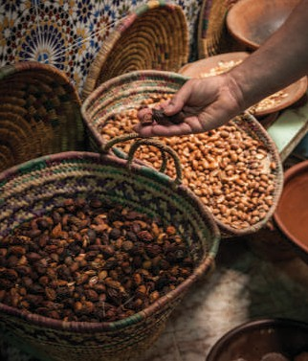 | 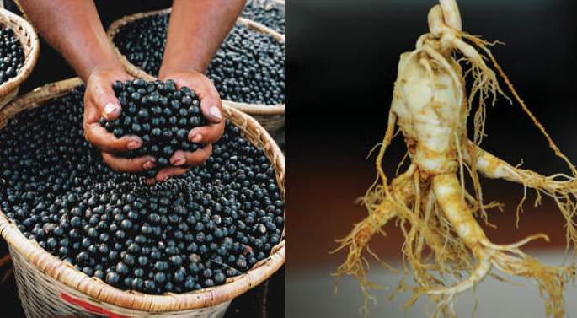
Argan Oil | The Acai Palm | Ginseng
The oil from argan nuts is very important to the people of southwestern Morocco.  It has many different uses.  It adds flavor 1 to food, it prevents dry skin, and it keeps hair soft. Now it is popular in other countries, too, and it is becoming more expensive. The production of argan oil cannot increase very quickly, because argan trees don’t produce nuts until they are about 20 years old.  ¹ flavor: a specific taste | The acai palm tree of Central and South America has round purple fruit. Acai is very important to some  of the tribes in the Amazon Rainforest. In fact, it is a very large part of their diet.2 People make both sweet  and salty dishes with acai. Now some companies say that acai helps people lose weight.  ² diet: a person’s regular food and drink | Ginseng is a plant that grows in Asia and North America. There are many different types of ginseng plants. Chinese medicine started using ginseng thousands of years ago to treat all kinds of diseases. According to some scientific studies, ginseng may help manage stress.3 Be careful, though! Too much ginseng can keep you awake at night.  ³ stress: mental or physical difficulty caused by work, worries, and so on

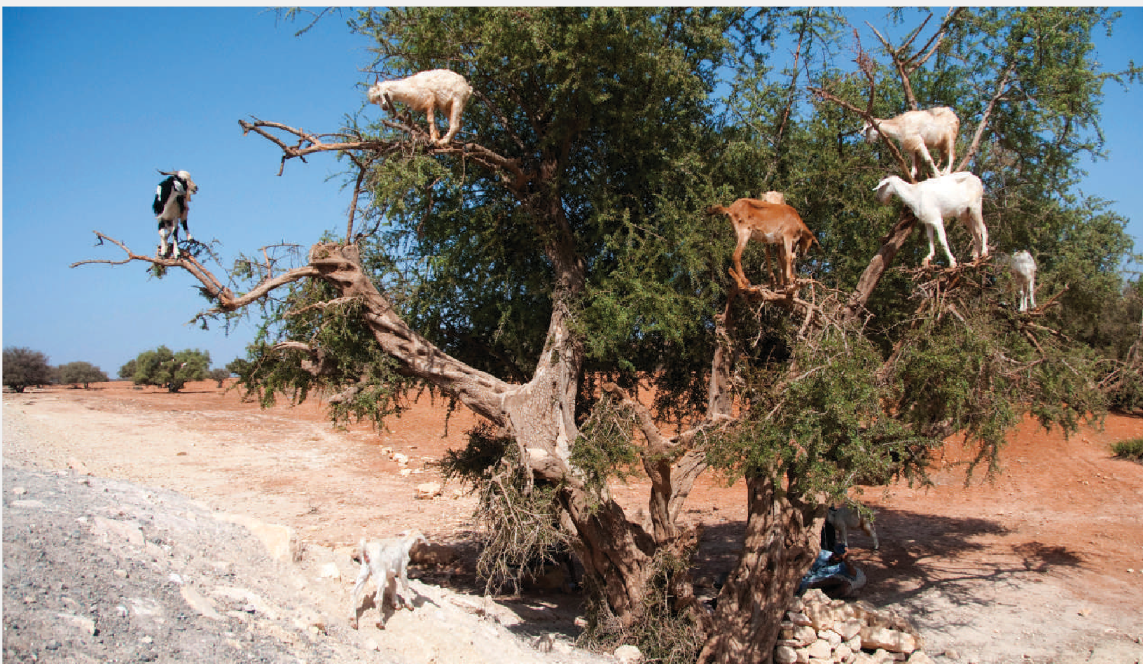
Goats in Morocco like argan nuts so much that they climb trees to
find them.
UNIT 3 LESSON 2 69
Copyright 2015 Cengage Learning. All Rights Reserved. May not be copied, scanned, or duplicated, in whole or in part. Due to electronic rights, some third party content may be suppressed from the eBook and/or eChapter(s).
Editorial review has deemed that any suppressed content does not materially affect the overall learning experience. Cengage Learning reserves the right to remove additional content at any time if subsequent rights restrictions require it.

- CHECK. Match each statement with the correct tree or plant. Write the letter on the line.
  - You can use it in sweet and salty meals. b a. argan oil

  - It keeps hair soft. b. acai palm

  - Tests suggest it can help you relax. c. ginseng

  - It is becoming more expensive.

  - According to some companies, it helps you lose weight.

  - Some people don’t sleep well because of it.

- DISCOVER. Complete the exercises to learn about the grammar in this lesson.
- Look at these sentences from the article in exercise 1. Notice the nouns in bold. Circle the nouns that name things you can count. Underline the nouns that name things you cannot count.
  - The oil from argan nuts is very important to the people of southwestern Morocco.

  - It adds flavor to food, prevents dry skin, and keeps hair soft.

  - Now some companies say that acai helps people lose weight.

- Work with a partner. Compare your answers from exercise A.

LEARN

Count Nouns and Non-Count Nouns
Non- Count Nouns
Count Nouns
 | Noun | Verb
A | doctor | is coming.
Many | doctors | are coming.

Noun | Verb
Health | is | important.
The coffee | tastes | good.

1. Count nouns name things that can be counted. They have a singular and plural form. | I ate an orange for breakfast.  I bought four oranges yesterday.
Use a or an before a singular count noun or an adjective + a singular count noun. | a building  an apartment  a small apartment
2. Non-count nouns name things that cannot be counted. They do not have a plural form. | happiness, beauty, information, science, snow, water  - Alaska gets a lot of snow.  ✗ Alaska gets a lot of snows.
Do not use a or an before a non-count noun. | - I need information.  ✗ I need an information.
3. Use singular pronouns and verb forms with non-count nouns. | - Rice is cheap, but I don’t like it.  ✗ Rice are cheap, but I don’t like them.
REAL ENGLISH
Some nouns can be count with one meaning and non-count with a different meaning.
She goes to the gym three times a week. (count)
I don’t have time to go to the gym today. (non-count) We had three exercises for homework last night. (count) Exercise is important for good health. (non-count)

- Circle the correct word(s) to complete each sentence.
  - Some people use argan oil to keep their hair / hairs soft.

  - Some companies says / say that acai helps people lose weight.

  - Chinese medicine is / are over 2000 years old.

  - Science is / are a difficult subject, but I enjoy it / them.

  - The store / stores on that street are sometimes expensive.

  - Apartment / An apartment is a convenient place to live.

  - Do you have any time / times to help me with my assignment?

  - Hans goes to Germany three or four time / times a year.

70 NOUNS

  - This information is / informations are incorrect.

  - Last night’s homework was / were very difficult.

  - That furniture is / are ugly. I don’t know why I bought it / them!

  - Did you have any interesting experience / experiences on your vacation?

More Non-Count Nouns
Categories of Non- Count Nouns
- Some non-count nouns name a category of related items. The related items are often count nouns.

- Some non-count nouns name things that do not have separate parts or pieces that can be counted.
- Some non-count nouns are abstract nouns. An abstract noun names an idea, a feeling, or a quality.
- The names of subjects of study are usually non-count nouns.
clothing (pants, sweaters, shoes) fruit (apples, oranges, bananas) furniture (tables, chairs, desks)
homework (essays, exercises, assignments) jewelry (necklaces, rings, bracelets) money (nickels, dimes, quarters)
mail (letters, packages, postcards) weather (hurricanes, storms, tornadoes)
air, cheese, coffee, fish, flour, hair, ice, juice, meat, milk, oil, rice, skin, soup, sugar, tea, water, wind
advice, beauty, energy, experience, fun, happiness, health, help, honesty, intelligence, knowledge, love, nature, work
biology, chemistry, geometry, history, math, science

- Read the sentences. Circle the non-count nouns. Then write the number of the correct category above each non-count noun. (1 = a category of related items, 2 = something that does not have separate parts, 3 = an abstract noun, 4 = a subject of study).

4
  - I’m taking six classes this semester, but I’m not taking biology.

  - I have a lot of homework this weekend. I have an essay due on Monday and two exams on Tuesday.
  - Please do not bring food or drinks into the museum, and please turn off your cell phones.

  - My uncle often has cheese and crackers before dinner.

  - I eat a lot of fruit. I usually have a banana, an orange, and two apples every day.

  - The café across the street has great coffee and delicious pastries.

  - For some jobs, experience isn’t very important.

  - I usually call my sister when I have a problem. She always gives me good advice.

  - We need to put money in the parking machine. It takes coins and dollar bills.

  - Sarah has a lot of energy. She works six days a week and takes classes at night.

  - Your mail is on the table. You got two letters and a package today.

UNIT 3 LESSON 2 71

PRACTICE
- Circle the correct word(s) to complete the conversations.

Conversation 1
Lori: Did you go to the supermarket?
Stan: Yes I did, but look! (1) The fruit is / fruit are rotten.
Lori: Let’s see . . . Oh, yes, (2) it smells / they smell bad.
Stan: The food in that store just (3) isn’t / aren’t good anymore. I’ve been there four or five
(4) time / times recently and there is always a problem.
Lori: Wait a minute, though. The bananas (5) look / looks all right.
Stan: You’re right. (6) It does / They do. But I’m going to take the rest back.

Conversation 2
Tina: Are you doing your physics (7) homework / homeworks, Brendan?
Brendan: Yes, but I need some (8) help / helps. I like physics, but (9) it’s / they’re difficult.
Tina: Well, I have some (10) time / times now. I can help you.
Brendan: Thanks, Tina. I don't understand this (11) exercise / exercises. These instructions
(12) isn’t / aren’t very clear.

- Complete the conversations with the nouns from the boxes. Make the nouns plural if necessary. You will need to use one noun twice.
advice assignment class fun homework time
Alex: Hey, Bruce. Do you want to go to the basketball game tonight?
Bruce: No, sorry. I don’t have (1) time . I have a lot of
(2) tonight.
Alex: That’s too bad. How many (3) are you taking this semester?
Bruce: Five. And I have an (4) for each of them.
Alex: Ugh! That is a lot. You need to study less and have more (5) .
Bruce: That seems like good (6) . Enjoy the game tonight!
energy exercise health time

72 NOUNS
Ellen: Hi, Junko. Where are you going?
Junko: To the gym. I was sitting in a meeting all day today. I need to get some (7) !
Ellen: Good for you! I’m so busy these days. I don’t have (8) to exercise.
How often do you go to the gym?
Junko: Oh, about three (9) a week. I often go early in the morning before work.
Ellen: Really? Do you feel tired afterwards?
Junko: No, I actually have more (10) after I work out.
Ellen: That’s great. And it’s good for your (11) , too.


CD1-20

LISTEN, WRITE & SPEAK.

- Listen to an interview with a doctor about the health benefits of certain kinds of food. Check the kinds of food you hear.

 green vegetables  beans
 apples  lettuce
 oranges  squash
 cabbage  fish
 nuts meat

Vegetables provide almost everything the human body needs.


CD1-20
- What are the health benefits of the kinds of food you heard in exercise A? Listen again.
Then write the name of each kind of food next to the correct health benefit(s).
  - important for our eyes
  - good for your skin
  - a great source of energy
  - strong muscles
  - Vitamin K
  - strong bones

- In your notebook, write five sentences about the different kinds of food in exercise A.

Squash is good for your eyes.
- Work with a partner. Compare your sentences from exercise C. Do you know of any other kinds of food that have special health benefits? Tell your partner.
A: Carrots are good for your eyes. B: Milk makes bones strong.

APPLY.
- Think about the kinds of food and drink you buy. Write five items of food or drink in each column of the chart. Next to each item, write C if it is a count noun or NC if it is a non-count noun.

What items of food and drink do you buy?
Often | Sometimes | Rarely
coffee (NC) | carrots (C) | soda (NC)
- Work with a partner. Talk about the items in your chart from exercise A. Pay attention to the verb forms and pronouns you use with count and non-count nouns.
A: I sometimes buy carrots. I put them in salads. B: Oh, I never buy them. They taste terrible!

- In your notebook, write five or six sentences about the items in your chart from exercise A. Pay attention to the verb forms and pronouns you use with count and non-count nouns.

UNIT 3 LESSON 2 73

Quantity and Measurement Words
LESSON 3

CD1-21

Manchester City is one of the top soccer teams in England. Here the players celebrate their 2012 Premier League success.

EXPLORE
- READ the article about sports science. Notice the words in bold.

The Science of Sports
When Manchester City soccer team won the English Premier League in 2012, there were many reasons for its success. The owners spent a lot of money on star players. The team also had a very good head coach.
However, one reason for the team’s success was less obvious. A lot of teams lose their star players for weeks or months because of injuries.1 Thanks to sports science, Manchester City players did not get hurt frequently, and did not lose much playing time.
During practice each Manchester City player wears a GPS monitor.2 Sports scientists then use the information provided by the monitor. They analyze each player’s movements, effort, and recovery.3 When practice is over, each player gets some vitamins. They also get a large bottle of a special drink. Each player’s drink is created especially for him. The drinks help keep the players healthy.
Some teams still do not take sports science seriously. However, spending a little money on sports science can greatly improve a team’s performance. Manchester City’s story is proof 4 of this.


































1 injury: damage to a person’s body
2 GPS monitor: a small computer that records a person’s movements
3 recovery: return to usual condition
4 proof: something that shows that something is true

74 NOUNS
Copyright 2015 Cengage Learning. All Rights Reserved. May not be copied, scanned, or duplicated, in whole or in part. Due to electronic rights, some third party content may be suppressed from the eBook and/or eChapter(s).
Editorial review has deemed that any suppressed content does not materially affect the overall learning experience. Cengage Learning reserves the right to remove additional content at any time if subsequent rights restrictions require it.



- CHECK. Choose the correct answer to complete each statement.

  - One reason for Manchester City’s success in 2012 was .
a. having good luck b. buying star players c. playing against weak teams

  - Compared to other teams, Manchester City players .
a. were younger b. did not play as much c. had fewer injuries

  - Players wear GPS monitors to .
a. record their performance b. stop them from getting lost c. make them work hard

  - After practice, each player gets .
a. his favorite cold drink b. a bottle of a special drink c. a large bottle of water

- DISCOVER. Complete the exercises to learn about the grammar in this lesson.
- Find these sentences in the article from exercise 1. Write the missing words.
  - . . . there were many for its success.

  - The owners spent a lot of on star players.

  - A lot of lose their star players for weeks or months because of injuries.

  - . . . Manchester City players did not get hurt frequently, and did not lose much .

  - However, spending a little on sports science can greatly improve a team’s performance.

- Look at each sentence in exercise A. Is the noun after the bold word(s) a count noun or a non-count noun? Write C for count noun or NC for non-count noun after each sentence.
- Work with a partner. Compare your answers in exercise B. Then choose the correct phrase to complete each statement.

1. We use much with . | a. count nouns | b. non-count nouns
2. We use many with . | a. count nouns | b. non-count nouns
3. We use a little with . | a. count nouns | b. non-count nouns
4. We use a lot of with . | a. count nouns | b. count nouns and non-count nouns

75
Copyright 2015 Cengage Learning. All Rights Reserved. May not be copied, scanned, or duplicated, in whole or in part. Due to electronic rights, some third party content may be suppressed from the eBook and/or eChapter(s).
Editorial review has deemed that any suppressed content does not materially affect the overall learning experience. Cengage Learning reserves the right to remove additional content at any time if subsequent rights restrictions require it.

LEARN

Quantity Words with Count and Non-Count Nouns
Count Nouns
Non- Count Nouns
 | Quantity Words
 | some
We have | a few  a lot of many | dishes. flowers.
 | any | glasses.
We don’t have | a lot of
 | many

 | Quantity Words
We have | some a little a lot of | money. time. work.
We don’t have | any  a lot of much

1. Use some with count and non-count nouns in affirmative statements. | We need some bananas.  I left some fruit on the table.
2. Use any with count and non-count nouns in negative statements. | Maria doesn’t want any oranges.  I don’t have any homework.
3. Use a few and many with count nouns. | I have a few questions.  Did you buy many apples?
4. Use a little and much with non-count nouns. | Give the plants a little water. We don’t have much homework tonight.
5. Use a lot of with both count and non-count nouns. | We bought a lot of vegetables.  She eats a lot of sugar.

- Circle the correct word(s) to complete each statement or question.
  - Manchester City has some / any star players.

  - Much / Many soccer teams lose players because of injury.

  - I usually go to a few / a little soccer games every year.

  - Michel didn’t score any / some goals in the last game.

  - We didn’t get much / many exercise last week.

  - A lot of / Much people left the game early.

  - Sally bought any / some new running shoes yesterday.

  - Marie wants to go ride her bike when she has a few / some time.

  - Were there much / many people in your yoga class this morning?

  - I didn’t find many / much mistakes in your assignment.

  - There is a little / a few ice cream left in the freezer.

  - Do you have much / many homework this weekend?

76 NOUNS

Measurement Words with Non-Count Nouns

    - Use a measurement word + of to talk about a specific quantity of a non-count noun.
Other
a piece of jewelry a piece of mail
Shape
a bar of chocolate a bar of soap
a loaf of bread a sheet of paper a stick of butter
a tube of toothpaste
Portion
a piece of cake a piece of pie a slice of bread a slice of pizza
Measurement
a gallon of milk a pint of ice
cream
a pound of meat a quart of oil
a tablespoon of sugar
a teaspoon of salt
Container
a bag of rice
a bottle of juice a bowl of cereal a box of cereal a can of soda
a carton of milk a cup of coffee a glass of water a jar of jam
    - Do not use a number before a non-count noun. Use a measurement word.
He drank a bottle of juice.
I bought three loaves of bread.

- Put two bars of soap in the bathroom.
✗ Put two soap in the bathroom.

- Circle the correct measurement word to complete each sentence.
  - Clive cut three slices / bars of pizza and put them on his plate.

  - I need to buy a new bar / tube of toothpaste.

  - Do you have a sheet / slice of paper? I need to write a shopping list.

  - Would you like a piece / loaf of pie for dessert?

  - This cake uses six bars / sticks of butter.

  - We will need three cartons / loaves of bread for the party.

  - I put a new bar / stick of soap in the bathroom.

  - Helena had a glass / bowl of cereal for breakfast.

  - Yoko is wearing five different slices / pieces of jewelry today.

  - Add two pounds / gallons of milk to the shopping list, please.

  - I didn’t get a single piece / sheet of mail today.

  - The mechanic put a quart / carton of oil in my car.

- SPEAK. Work with a partner. Student B closes his or her book. Student A reads measurement words from chart 3.7. Student B says any correct noun for each measurement word. Switch roles after five or six measurement words.
A: a can of . . .
B: a can of beans

UNIT 3 LESSON 3 77

PRACTICE
- Circle the correct word or phrase to complete the blog post.
Help! What Can I Eat?
[posted by runnergirl at 8:22pm, Jan. 2]
I am a runner, so I take (1) many / much / a lot of interest in my diet, but sometimes it can be so confusing! For years, doctors said, “You need to drink eight 8-ounce
(2) cans / glasses / tubes of water every day,” but now (3) some / a little / any researchers don’t agree. Also, I hear about a new diet almost every day. “To lose weight and stay healthy, don’t eat (4) much / a few / any grains.” Or, “You can eat (5) a little / any / some grains, but
(6) not much / not many / any. For example, if you eat a sandwich, use only one (7) sheet / loaf / slice of bread.” How do I do that? I already know I shouldn’t eat (8) a little / many / much sugar. I won’t drink even one (9) bowl / can / carton of soda because there are around nine (10) teaspoons / bars / pieces of sugar in each can. But what about juice?
I bought a (11) jar / glass / bottle of juice last week, and it had more sugar than the soda. Is
that OK? Please help me.
- SPEAK. Work with a partner. Discuss the advice you might give to the writer. Use quantity and measurement words with the kinds of food and drink she writes about in exercise 7.
A: I think it’s a good idea to drink a lot of water.
B: I agree. The writer shouldn’t drink much juice. It’s better to eat a piece of fruit.

- Complete the sentences with the words or phrases from the box.

a little | any | bowl | much | pound
a lot of | bar | jar | piece | some
  - A calorie is a measure of energy in food. High-sugar foods have a lot of calories.

  - We need to buy food with protein. How about a small of peanut butter and a of sliced turkey from the deli?
  - If you don’t want to eat grains, then you can’t eat that
of cereal or that of cake!

  - There isn’t milk left. I’ll get later.

  - I used to eat a big of milk chocolate every day. Now I only eat
dark chocolate occasionally.

78 NOUNS


CD1-22

LISTEN, WRITE & SPEAK.
- Work with a partner. Look at the different kinds of diets and food listed in the chart. What do you know about them? Tell your partner.
- Listen to three friends talk about their diets. Which kinds of food are OK to eat on each diet?
Put ✓ in the chart if it is OK, put X if it is not OK, and put ? if you are not sure.

Do You Want to Eat Like a Caveman?
Diet Comparisons | Low-Fat Diet | Vegetarian Diet | Vegan Diet | Paleo Diet
vegetables
fruit
grain
meat/protein |  |  | ✗
dairy |  |  |  | ?
sugar

- Compare your chart from exercise B with a partner. Then write six sentences about the diets in your notebook. Use much, many, a few, a little, some, and a lot of.

On the Paleo diet, people don’t eat any grains. They eat some fruit, but they don't eat candy or other sweets.
- Share your sentences from exercise C with a partner. Then discuss any other information you remember from the conversation.
- Work in a small group. Discuss your thoughts and opinions about the different diets.

A: I don’t think low-fat diets are a good idea. I think eating a lot of sugar is a bigger problem.
B: I agree. Even organic sweets can have too much sugar. They seem healthy, but they aren’t.


The Paleo diet is sometimes called the “caveman diet.” People believe you should eat whole foods, not processed or fast foods. (Graffiti
art by Banksy, Los Angeles, CA).
UNIT 3 LESSON 3 79
Copyright 2015 Cengage Learning. All Rights Reserved. May not be copied, scanned, or duplicated, in whole or in part. Due to electronic rights, some third party content may be suppressed from the eBook and/or eChapter(s).
Editorial review has deemed that any suppressed content does not materially affect the overall learning experience. Cengage Learning reserves the right to remove additional content at any time if subsequent rights restrictions require it.

EDIT & SPEAK.
- Read the paragraph about a fitness program. Find and correct seven more errors with quantity words and measurement words.
My New Fitness Program
a lot of
I wasn’t always fit. I used to eat many fast food, such as hamburgers and pizza, and I didn’t get many exercise. I wasn’t very happy. I wanted to lose any weight and feel fit and healthy.
I didn’t want to go on a special diet. Much diets have a lot of rules, and I want to enjoy a sheet of pizza or a jar of ice cream sometimes. Then, a little months ago, I found a great new fitness plan online. The plan lets me eat different kinds of food. I even have dessert a little times a week.
I take a walk or ride my bike every morning. Now I’m fit and healthy, and I feel great!
- Work in a small group. Discuss the following questions.
  - Do you think the writer’s fitness plan from exercise A sounds like a good one? Why, or why not?

  - Do you know about any special diets or fitness plans? Do you think they work? Why or why not?

APPLY.
- How fit and healthy are you? Complete the chart with sentences about some of your healthy and unhealthy habits. Use quantity words and measurement words.

Healthy Habits Unhealthy Habits
I eat a lot of vegetables. | I have a bowl of ice cream for dessert every night.

- Work with a partner. Share the information from your chart in exercise A. Ask your partner questions for more information about his or her healthy or unhealthy habits.
A: I eat a lot of vegetables.
B: What do you usually have for lunch?
A: A salad or a bowl of soup.
- Form a group with another pair of students. Take turns talking about some of your partner’s healthy and unhealthy habits. Use quantity words and measurement words.
Antonio gets a lot of exercise. He goes to the gym about five times a week. He also eats a lot of vegetables, but he usually drinks one or two cans of soda every day . . .

80 NOUNS
Copyright 2015 Cengage Learning. All Rights Reserved. May not be copied, scanned, or duplicated, in whole or in part. Due to electronic rights, some third party content may be suppressed from the eBook and/or eChapter(s).
Editorial review has deemed that any suppressed content does not materially affect the overall learning experience. Cengage Learning reserves the right to remove additional content at any time if subsequent rights restrictions require it.

Charts 3.4, 3.6
UNIT 3 Review the Grammar

Charts 3.1, 3.4–
3.6

Charts 3.4, 3.6
- Complete the conversations with a, an, or some.

Conversation 1
Piet: I just bought (1) a new bike.
Mauro: Oh, that’s (2) good idea.
Piet: Yes, I really need to get (3) exercise.
Mauro: Hmm, well, I have (4) time off tomorrow. Do you want to go for (5) ride together?

Conversation 2
June: Would you like (6) cup of coffee?
Belinda: No, thanks. I just had (7) coffee about fifteen minutes ago.
June: Would you like (8) glass of lemonade instead?
Belinda: Yes, that would be great.
June: I also have (9) fruit. I have apples, oranges, and pears.
Belinda: I’d love (10) orange. Thanks, June.

- Complete the sentences with one of the nouns in parentheses. Make the noun plural if necessary.
  - This gym has many new machines (machine / equipment).

  - My old gym didn’t have much (machine / equipment).

  - Taylor’s children don’t eat much (fruit / apple).

  - How many (fruit / apple) did you use in the pie?

  - I learned an interesting (fact / information) about nutrition yesterday.

  - There was a lot of interesting (fact / information) on the website.

  - My doctor gave me a few good (advice / suggestion) about my diet.

  - Doctor Carson didn’t give me much (advice / suggestion) about exercise.

- Circle the correct word(s) to complete each statement or question.
  - Do you play much / many different sports?

  - My father rides his bike a few / a little times a week.

  - Much / Many people like to exercise in the morning.

  - I don’t take any / some vitamins, but I have a healthy diet.

  - Elsie spends a lot of / many time at the gym. She’s very fit.

UNIT 3 REVIEW THE GRAMMAR 81
Copyright 2015 Cengage Learning. All Rights Reserved. May not be copied, scanned, or duplicated, in whole or in part. Due to electronic rights, some third party content may be suppressed from the eBook and/or eChapter(s).
Editorial review has deemed that any suppressed content does not materially affect the overall learning experience. Cengage Learning reserves the right to remove additional content at any time if subsequent rights restrictions require it.

  - Only a few / a little people were at the gym last night. It was almost empty.
UNIT 3
Review the Grammar UNIT 3

  - She gave us any / some advice about yoga classes.

  - I found a few / a little information about that diet online, but not much.

  - I asked Paula about fitness classes. She gave me any / some good suggestions.

  - How much / many pieces of fruit do you usually eat a day?

Charts 3.4–3.6
- EDIT. Read the information about the health of Siamese crocodiles. Find and correct eight more errors with count and non-count nouns and quantity words.









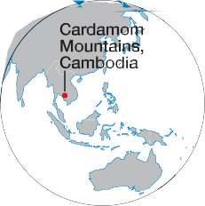
Why the Health of Siamese Crocodiles Matters

Many
Much species of wild animals are dying out.1 This is huge problem. The healths of one group of living things often depends on another group of living things. This is true for humans, too.
An good example of this is in Cambodia. In 2000, scientist Jenny Daltry took a team of scientist into Cambodia’s Cardamom Mountains. She wanted to make a list of the different kinds of animals there. Daltry’s team discovered much Siamese crocodiles there. There were 150!
The crocodiles live in marshes. Marshes are soft wet areas of land with much plants. The crocodiles help keep the marsh areas wet and alive. They dig mud2 out of the marshes and help keep a water there, even during the dry season. As a result, other animals have a good source of waters. This is also helpful to humans.

1 die out: disappear forever
2 mud: a mixture of earth and water

Siamese crocodiles are in danger of dying out.

82 NOUNS
Copyright 2015 Cengage Learning. All Rights Reserved. May not be copied, scanned, or duplicated, in whole or in part. Due to electronic rights, some third party content may be suppressed from the eBook and/or eChapter(s).
Editorial review has deemed that any suppressed content does not materially affect the overall learning experience. Cengage Learning reserves the right to remove additional content at any time if subsequent rights restrictions require it.

Charts 3.1–3.6

CD1-23–27

LISTEN & SPEAK.
- Listen to five people talk about their fitness activities. Match the information in Column B with the correct speaker in Column A. Write the letters on the lines.

Column A
Speaker 1 c Speaker 2 Speaker 3
Speaker 4 Speaker 5

Column B
  - plays many different sports
  - enjoys a dangerous sport
  - is training for a race
  - roommate’s father is a coach
  - is using someone else’s bike
  - gets a lot of injuries
  - doesn’t do much running
  - isn’t interested in team sports


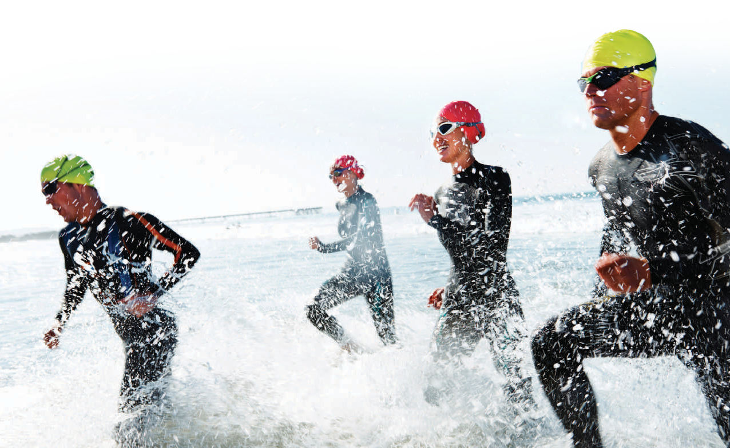
- Work with a partner. Compare your answers from exercise A. Then talk about each of the speakers. Use the information from exercise A and any other information you remember.
Speaker 1 is starting a new sport. She rode her friend’s bike three times last week.

- Look at the list of sports and other fitness activities from exercise A in the box below. Which of these activities do you enjoy? Do you like to watch any of these sports or activities? What do you know about them? Discuss your answers with your partner. Use quantity words, another, other, and the other when appropriate.

basketball | football | skiing | volleyball
cycling | running | swimming | yoga
I swim a few times a week. It’s really good exercise.
I also like to watch football. It’s interesting, but there are a lot of rules. I don’t understand many of them! I like a lot of other sports, too...

A group of athletes competing in a triathlon

83
Copyright 2015 Cengage Learning. All Rights Reserved. May not be copied, scanned, or duplicated, in whole or in part. Due to electronic rights, some third party content may be suppressed from the eBook and/or eChapter(s).
Editorial review has deemed that any suppressed content does not materially affect the overall learning experience. Cengage Learning reserves the right to remove additional content at any time if subsequent rights restrictions require it.

READ & NOTICE THE GRAMMAR.
Connect the Grammar to Writing
  - Work with a partner. What do you think is the best way to stay fit? Discuss your ideas with your partner. Then read the text.
Staying Fit
Exercise is important if you want to stay fit. You don’t need any fancy machines or a lot of expensive clothing. The best exercise, in my opinion, is to take a long walk every day. Walking is inexpensive, easy, and safe.
All you need for a walk are comfortable shoes, appropriate clothing, and 30 minutes to an hour of your time. If it’s warm and you live near a beach, you don’t even need any shoes! Walking takes very little time and money.
A walk is also a safe way to stay fit. Often people get hurt when they exercise. Some people run several miles a week and then complain of knee or back pain. Other people do a lot of drills1 and then ache for a week. Walking is relaxing and does not put a lot of stress on your body. It provides exercise without additional pain. Walking keeps your body—and your mind—healthy. Go take a walk!

1 drill: a practice exercise that you repeat again and again

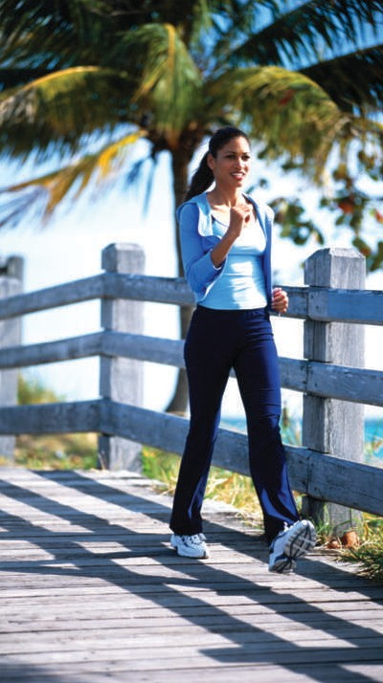
GRAMMAR FOCUS
In the text, the writer uses singular and plural count nouns and non-count nouns both with and without adjectives and quantity words. Notice the articles and quantity words.

Count Nouns | Singular with a/an: Plural:  Quantity word: | The best exercise, . . . is to take a long walk . . .  All you need . . . are comfortable shoes . . .  You don’t need any fancy machines . . .
Non-Count Nouns | (No a/an): Quantity word: | Exercise is important if you want to stay fit.  You don’t need . . . a lot of expensive clothing.

  - Read the text in exercise A again. Complete the chart with count and non-count nouns. Include possessive adjectives or quantity words. Find at least one more for each category.

Nouns | (Adjective) + Noun (with or without a/an) | Quantity Word + (Adjective) + Noun
Count | your body | any shoes
Non-Count | The best exercise | little time
84 NOUNS
Copyright 2015 Cengage Learning. All Rights Reserved. May not be copied, scanned, or duplicated, in whole or in part. Due to electronic rights, some third party content may be suppressed from the eBook and/or eChapter(s).
Editorial review has deemed that any suppressed content does not materially affect the overall learning experience. Cengage Learning reserves the right to remove additional content at any time if subsequent rights restrictions require it.

Write Opinion Paragraphs
WRITING FOCUS
Subject-Verb Agreement with Count and Non-Count Nouns
When using nouns in the subject position, be sure to use the correct singular or plural form of the verb. With non-count nouns as subjects, use a singular verb.
Singular Count: A walk is also a safe way to stay fit.
Plural Count: Often, people get hurt when they exercise.
Non-Count: Exercise is important if you want to stay fit.

  - In exercise A, the writer states an opinion and the reasons for it. Then she uses facts to support her reasons. Complete the chart with her reasons and supporting facts.

Opinion: The best way to stay fit is to take a long walk.
Reason 1: It’s easy and inexpensive.
Supporting Facts: 1. You only need a comfortable pair of shoes and some appropriate clothing.
2.
Reason 2:
Supporting Facts:

BEFORE YOU WRITE.
  - Work with a partner. What type of exercise or diet do you feel is best? Discuss your ideas with a partner.
  - Make a chart in your notebook like the one in exercise 1C. Complete the chart with your opinion about a good way to stay fit and your supporting facts. Use the ideas you and your partner discussed.

- WRITE your opinion about a good way to stay fit. Write three paragraphs and give at least two reasons for your opinion. Be sure to give support. Use the information in your chart from exercise 2B and the text in exercise 1A to help you.

- SELF ASSESS. Read your paragraphs and underline the count nouns, non-count nouns, and quantity words. Then use the checklist to assess your work.
 I used a or an before singular count nouns. [3.4]
 I did not use a or an before plural count nouns and non-count nouns. [3.4]  I used some in affirmative statements and any in negative statements. [3.6]  I used the correct singular or plural form of verbs. [WRITING FOCUS]
UNIT 3 CONNECT THE GRAMMAR TO WRITING 85
Copyright 2015 Cengage Learning. All Rights Reserved. May not be copied, scanned, or duplicated, in whole or in part. Due to electronic rights, some third party content may be suppressed from the eBook and/or eChapter(s).
Editorial review has deemed that any suppressed content does not materially affect the overall learning experience. Cengage Learning reserves the right to remove additional content at any time if subsequent rights restrictions require it.

